

**Laboratory Safety Manual**

|  |  |
| --- | --- |
| C:\Users\pedrolimaduarte\AppData\Local\Microsoft\Windows\Temporary Internet Files\Content.IE5\NLPWIMBU\laboratorio[1].png | C:\Program Files\Microsoft Office\MEDIA\CAGCAT10\j0302827.jpg |

Safety, Hygiene and Health Unit (NSHS)

**November 2016**

**Table of Contents**

Pages

[1. Introduction 1](#_Toc492022565)

[2. Emergency Contacts 2](#_Toc492022566)

[3. Basic Safety Rules 3](#_Toc492022567)

[3.1. Safety Equipment 3](#_Toc492022568)

[3.2. Prior preparation of the experimental work 3](#_Toc492022569)

[3.3. General safety rules 4](#_Toc492022570)

[3.4. Handling chemical products 5](#_Toc492022571)

[3.5. Handling equipment 6](#_Toc492022572)

[3.6. Safety Signaling 6](#_Toc492022573)

[4. Accidents 12](#_Toc492022574)

[4.1. In the event of an accident that endangers physical integrity of individuals 12](#_Toc492022575)

[4.2. In the event of an accident that endangers integrity of the building and/or its occupants 13](#_Toc492022576)

[5. Fire 14](#_Toc492022577)

[5.1. Classes of fire and extinguishing agents 14](#_Toc492022578)

[6. Chemical Products: Risk and Safety 17](#_Toc492022579)

[6.1. Identification/labeling and warning signals/symbols 17](#_Toc492022580)

[6.2. Storage of chemical substances 19](#_Toc492022581)

[6.3. Incompatible reactants 20](#_Toc492022582)

[6.4. Hazard Statements (H) e and Precautionary Statements (P) 20](#_Toc492022583)

[6.5. Safety Data Sheets (SDS or MSDS) 21](#_Toc492022584)

[6.6. Compressed gases 23](#_Toc492022585)

[6.6.1. Potential hazardous associated with compressed gases 23](#_Toc492022586)

[6.6.2. Identification of gases cylinders by colours 24](#_Toc492022587)

[6.6.3. Gas storage and use 24](#_Toc492022588)

[7. Physical hazards 27](#_Toc492022589)

[8. Radioisotopes 28](#_Toc492022590)

[8.1. Handling radioisotopes 28](#_Toc492022591)

[8.2. Preventive rules to reduce risks associated with radioisotope handling 29](#_Toc492022592)

[8.2.1. Safety in the facility 29](#_Toc492022593)

[8.2.2. Individual safety 29](#_Toc492022594)

[8.2.3. Safety during handling 30](#_Toc492022595)

[8.2.4. After radioisotope handling 30](#_Toc492022596)

[8.3. Radioactive waste management and storage 31](#_Toc492022597)

[9. Biological Agents 32](#_Toc492022598)

[10. Personal Protective Equipment 33](#_Toc492022599)

[11. Waste 35](#_Toc492022600)

[12. Bibliography 36](#_Toc492022601)

[Annex I – Reading register of the laboratory safety manual 1](#_Toc492022602)

[Annex II – Accidents that may occur in the laboratory and procedures to be adopted. 3](#_Toc492022603)

[Annex III – Emergency Leaflet 5](#_Toc492022604)

[Annex IV – Fire Leaflet 6](#_Toc492022605)

[Annex V – Incompatible chemical products 7](#_Toc492022606)

[Annex VI – Hazard Statements (H statements) and Precautionary Statements (P statements) 9](#_Toc492022607)

[Annex VII - NSHS 07/2011 Procedure – Waste Management at IST 14](#_Toc492022610)

**Table Index**

Pages

[Table 1. Classes of fire. 15](#_Toc466554976)

[Table 2. Forms of extinguishing and dealing with fire 15](#_Toc466554977)

[Table 3. Extinguishing agent depending on the class of fire 16](#_Toc466554978)

[Table 4. Chemical hazard pictograms. 18](#_Toc466554979)

[Table 5. SDS Sections 22](#_Toc466554980)

[Table 6. Gas cylinder colour coding 24](#_Toc466554981)

[Table 7. Physical hazards and respective protective measures. 27](#_Toc466554982)

[Table 8. Classification of biological agents (DL 84/97, of 16 April). 32](#_Toc466554983)

[Table 9. Types of personal protective equipment. 33](#_Toc466554984)

**Figure Index**

Pages

[Figure 1. Danger/Warning signals. 7](#_Toc440984423)

[Figure 2. Obligation signals. 8](#_Toc440984424)

[Figure 3. Emergency signals. 9](#_Toc440984425)

[Figure 4. Prohibition signals. 10](#_Toc440984426)

[Figure 5. Fire-fighting material signs. 11](#_Toc440984427)

[Figure 6. Fire triangle. 14](#_Toc440984428)

[Figure 7. Label example. 17](#_Toc440984429)

# Introduction

Protect all laboratory users from safety and health hazards at the workplace has gained increasing importance, because existing risks in these places are different in nature and linked to handling equipment, chemical products, biological agents and radioactive products.

In this regard, in order to prevent and mitigate said risks, it is mandatory to adopt a safety culture, which necessarily involves risk awareness. For the purpose, prior and careful planning and preparation of all laboratory/experimental work is critical, which should involve awareness of risks and safety associated with handling reactants, intermediate and finished products as well as equipment.

Laboratory safety is essential to ensure that the work is done properly and the health of users is kept safe, as any distraction may compromise the safety of users themselves and of others.

Below are listed some fundamental aspects related to safety:

* Safety must be faced as an attitude;
* Safety rules are set for everyone, but they depend on individual behaviour;
* Prevention should mean safety;
* Everyone must be aware of/sensitive to safety issues and take action accordingly;

In organizing this manual we have looked to address different issues related to laboratory safety in order to give the laboratory user a useful tool. Thus, we have sought to include the most relevant information, in addition to several annexes. **Each laboratory should provide specific information for its manual, for instance safety data sheets (SDS) of the products used, risk prevention data sheets (see examples on the NSHS webpage), safety instructions for handling equipment (these instructions should be elaborated by users under the supervision of laboratory managers. The information should be taken from instruction manuals of the respective equipment).**

This safety manual must be read (and the reading should be registered) by all laboratory users of IST. Annex I – Reading register of the laboratory safety manual includes the manual reading registering draft. Responsibility for maintaining the register lies with each laboratory manager who should send a copy to the President of the respective Department and/or Centre. The manual should also be made available in English for all foreign users. The manual is available on the NSHS webpage.

# Emergency Contacts

Below you can find the most important contacts in case of accident/emergency. For procedures in case of emergency, refer to chapter 4.

|  |  |
| --- | --- |
| Security Centre (Alameda Campus) | 2000  218 418 000 |
| Reception (Taguspark Campus) | 5002  210 405 002 |
| Entrance (Campus Tecnológico e Nuclear) | 6006  6007  219 946 000 |
| European Emergency Number | 112 |
| Poison Information Centre | 808 250 143 |
| Public Security Police (PSP)  (12th Police Station - Olaias)  Lisbon Metropolitan Command  Loures Division  Porto Salvo - Oeiras – 82th Police Station | 218 414 250  217 654 242  219 946 760  214 540 350 |
| Firefighters  Lisboa Fire Brigade  Sacavém Fire Brigade  Barcarena Firefighters | 808 215 215  219 427 914  214 213 900 |
| Municipal Civil Protection  Lisbon  Loures  (Number of Emergency)  Oeiras | 213 236 200  213 236 137  211 151 470  800 966 112  214 241 400 |
| Civil Protection (Lisbon District Centre for Aid Operations) | 218 820 960 |

**Note:** In most situations, please contact the European Emergency Number.

# Basic Safety Rules

## Safety Equipment

It is mandatory that laboratories be fitted with or close to the following safety equipment:

* Emergency fire blanket;
* Portable fire extinguisher;
* Spill-over sands or kits (places where liquid spillage may occur);
* Shower (laboratories with chemical products);
* Eyewash units (laboratories with chemical products);
* First aid kit (NSHS - 11/2016 procedure);
* Personal Protective Equipment (PPE).

Prior to the beginning of any laboratory activity, users must make sure that the above equipment is available, where it is located and whether is working properly. If any of the equipment is lacking or is not working properly the Laboratory Manager and/or the Building Manager must be informed immediately.

## Prior preparation of the experimental work

* Prepare in advance any experimental work. Make sure that you are informed of all potential hazards as a result of reactants, products, equipment and techniques to be used;
* Inform in advance of all risks and safety involved in handling reactants/chemical products (initial reactants, intermediate and end products), and refer to available information for the purpose (symbols and danger warnings, signal words, hazard statements (H statements), Precautionary statements (P statements) in labels, brochures and safety data sheets of products to be used);
* Get to know in advance risks and safety entailed in the techniques to be used;
* Prepare correctly the disposal of waste in compliance with the NSHS procedure (see chapter **Error! Reference source not found.**);
* Before using any equipment for the first time, always read the respective instruction manual.

## General safety rules

* Follow the instructions supplied by the professor/supervisor carefully;
* Refer to the Laboratory Safety Manual;
* Wear safety goggles where required;
* Never work alone in the laboratory, except otherwise authorised by the Laboratory Manager;
* Do not play in the laboratory;
* Do not smoke in the laboratory;
* Do not eat or drink in the laboratory;
* Never carry out unauthorised experiments. **Every procedure and equipment should be expressly authorised.** New experiments should be expressly authorised by the Laboratory Manager;
* Make sure that you know your escape routes and where emergency exits are located as well as safety equipment and how it is used;
* Place every personal objects in appropriate places (backpacks, bags, clothes, …);
* Refrain from wearing rings in the laboratory, as irritant products may appear under them;
* Do not wear necklaces or ties;
* Always wear a lab coat, which ensures adequate protection. Do not wear it outside the laboratory;
* Avoid contact of any substance with your skin;
* Wear adequate gloves where appropriate (when handling aggressive substances for your skin or that penetrate the outer layer of your skin); Gloves must be removed before touching doors, door handles, telephones, notebooks, computer keyboards,…;
* Do not wear contact lenses in the laboratory. Contact lenses are difficult to remove if any chemicals are splashed into your eyes or if any strange substance enters your eyes.
* Your body must be protected as much as possible. Wearing sandals/slippers/open shoes and/or highly flammable tissues is not allowed (closed, slip resistant footwear should be used instead). If you have got long hair keep it tied in the course of any experiment, in order to avoid contact with reactants or other material/equipment;
* Where necessary wear goggles; Where there is a risk of projection of chemical products/particles refrain from working with your face being exposed;
* Keep the place clean and tidy and with unobstructed circulations. An appropriate organisation of the working space avoids/mitigates the occurrence of working accidents;
* Do not place heavy recipients or containing dangerous liquids at a level above your head or located at difficult-to-access sites;
* The use of a height adjustable support is very useful when assembling systems composed by several parts, wherefore by carrying out assembly operations a stable structure must be ensured. Glass material used and fixed by means of clamps, clutches or tweezers must not be overtightened, because excessive tension may break it, in particular if temperature variations should occur;
* Do not place solid material inside sinks or drains;
* Do not place solvents/solvent residues in sinks or drains. Adequate recipients must be placed for the purpose and carry correct identification (see chapter **Error! Reference source not found.**);
* Comply with adequate waste disposal procedures (see chapter **Error! Reference source not found.**);
* Do not put broken glass in the garbage. A specific receptacle must exist for glass fragments;
* Check whether the laboratory is safe when you leave it. Check whether there are open water and gas taps or unduly connected equipment. If gas cylinders are used, close main valve and unload the hand reducer of the respective cylinders;
* Always wash your hands and your face before leaving the laboratory if necessary;
* Do not leave the laboratory with the PPE.

## Handling chemical products

* Never pipet solutions with your mouth;
* Never take in, inhale or touch with your hands a chemical product;
* Never let bottles containing volatile flammable solvents (acetone, alcohol, ether,…) near flames;
* Never let bottles containing volatile flammable solvents exposed to sunlight;
* Refrain from opening several bottles of the same product at the same time;
* Identify clearly all receptacles in accordance with labelling standards (see chapter 6.1). Never use a package/receptacle where you not sure about its content.
* Make sure that the reactants stored at low temperature reach ambient temperature before they are opened.
* Check whether the cylinders containing gases under pressure are duly bound with chains or straps;
* Always add any reactant slowly and never at one time only. See what happens when a small initial amount of reactant is added and wait some seconds before adding more reactant. Some reactions take some time to occur;
* When preparing aqueous solutions diluted in an acid, pour concentrated acid on water and never the opposite; always add slowly concentrated solutions on more diluted solutions or on water in order to avoid violent reactions;
* Never heat a test tube directing the open end to a colleague or to yourself;
* Should gases and/or toxic vapours occur, the experiment must be carried out in a hotte;
* Reactants and equipment must be arranged and put back in their right place after use;
* Never exceed the amount of reactant necessary for the experiment. If the amount is exceeded, never place the original bottle back, but place it in a package with similar characteristics and duly labelled. The chemical product may be contaminated;
* Do not store oxidising substances next to volatile flammable liquids;
* Do not heat flammable liquids with open flame;
* In the event of a chemical spill, you should wash the place immediately; spillage absorption kits may also be used.

## Handling equipment

* The Laboratory Manager must seek to ensure that all users have access to information necessary for the use of equipment;
* Before using the equipment for the first time, always read the respective instruction manual;
* Elaborate safety instructions for the equipment at issue and annex them to the laboratory safety manual;
* Always ensure that the equipment is in proper working and safety conditions;
* Check whether the equipment keeps the manufacturer’s recommended preventive maintenance in order;
* Use recommended PPE;
* Do not remove equipment safety protections because it may give rise to serious accidents.

## Safety Signalling

Safety signalling aims at providing information about and calling attention to, efficiently and unambiguously, potentially hazardous objects and situations and to remember adequate instructions and procedures in specific situations.

The aim of calling workers’ attention quickly and smartly may be achieved through different types of signals (see examples in Figure 1; Figure 2; Figure 3; Figure 4 and Figure 5). Additional examples may be observed in the signalling catalogue.

|  |
| --- |
| 6  Harmful or irritating substances  Low temperature  Biological hazard  Drop below  Trip hazard  Strong magnetic field  Non-ionising radiations  Oxidising substances  Laser beams  Several hazards  Load handling equipment  Electrical shock hazard  Suspended loads  Radioactive substances  Corrosive substances  Toxic substances  Explosive substances  Flammable substances or high temperature |

Figure 1. Examples of danger/warning signs. Triangular shape, black contour and pictogram and yellow background. *in* Miguel, Alberto Sérgio S. R. (2000), Manual de Higiene e Segurança do Trabalho, Porto, Porto Editora, 5th Edition

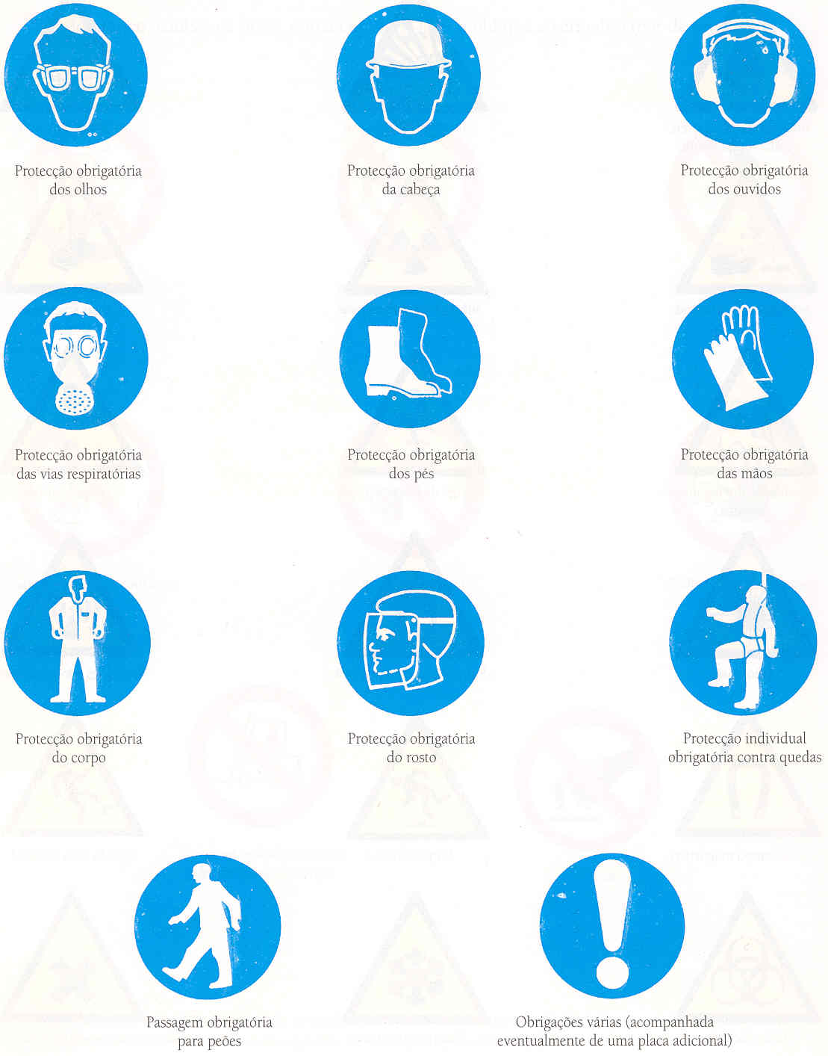

Fall-protection equipment must be worn

Several obligations (accompanied by an additional sign, if necessary)

Pedestrian crossing mandatory

Face protection must be worn

Body protection must be worn

Hand protection must be worn

Feet protection must be worn

Respiratory protection must be worn

Head protection must be worn

Ear protection must be worn

Eye protection must be worn

**Figure 2.** Examples of obligation signals. White pictogram and blue background. *in* Miguel, Alberto Sérgio S. R. (2000), Manual de Higiene e Segurança do Trabalho, Porto, Porto Editora, 5th Edition

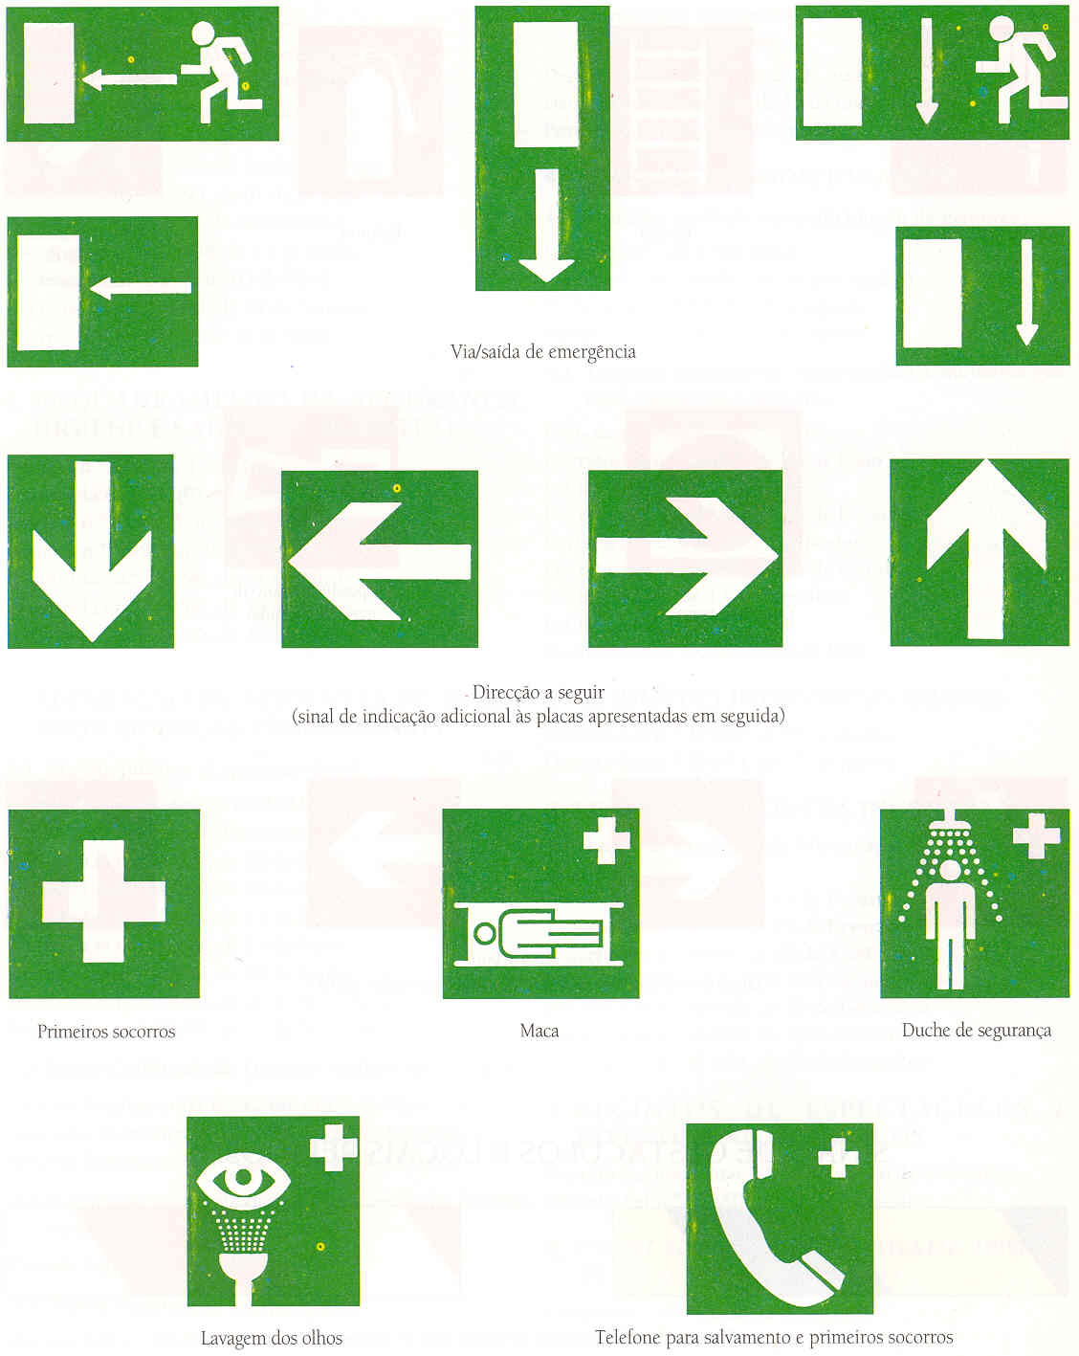

Telephone for rescue and first aid

Eye wash spot

Litter

Safety shower

First aid

Direction to go  
(additional indication sign to the signposts below)

Emergency lane/exit

**Figure 3.** Examples of emergency signs. White pictogram and green background. *in* Miguel, Alberto Sérgio S. R. (2000), Manual de Higiene e Segurança do Trabalho, Porto, Porto Editora, 5th Edition

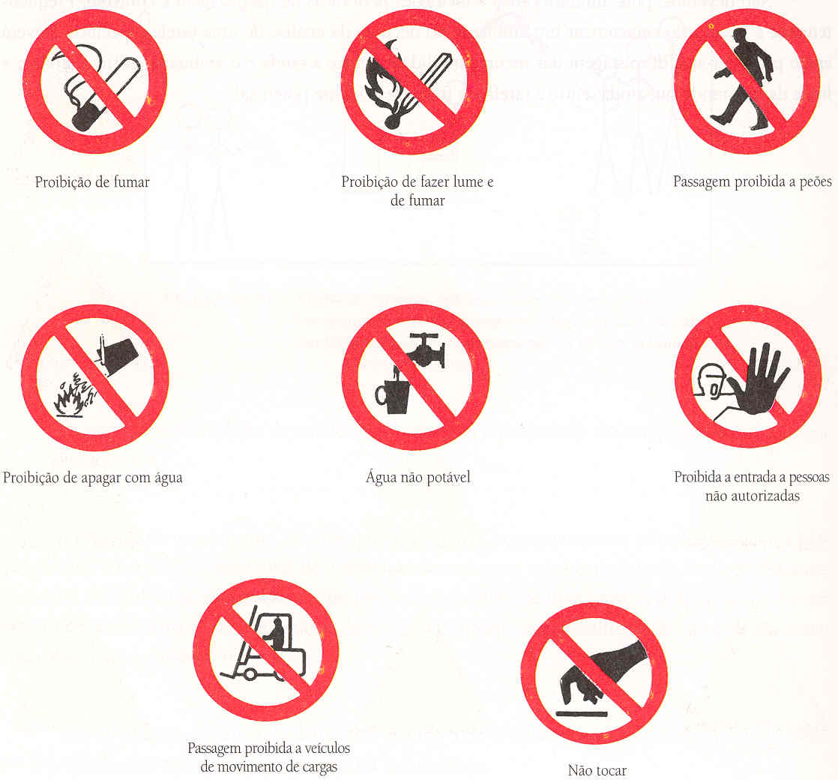

Forklift traffic not allowed

Do not touch

No unauthorized persons allowed beyond this point

No drinking water

Do not extinguish with water

No sparks, flames or smoking

No pedestrian access

No smoking

Figure 4. Examples of prohibition signs. Black pictogram, circular annulus and red oblique slash and white background. *in* Miguel, Alberto Sérgio S. R. (2000), Manual de Higiene e Segurança do Trabalho, Porto, Porto Editora, 5th Eidtion

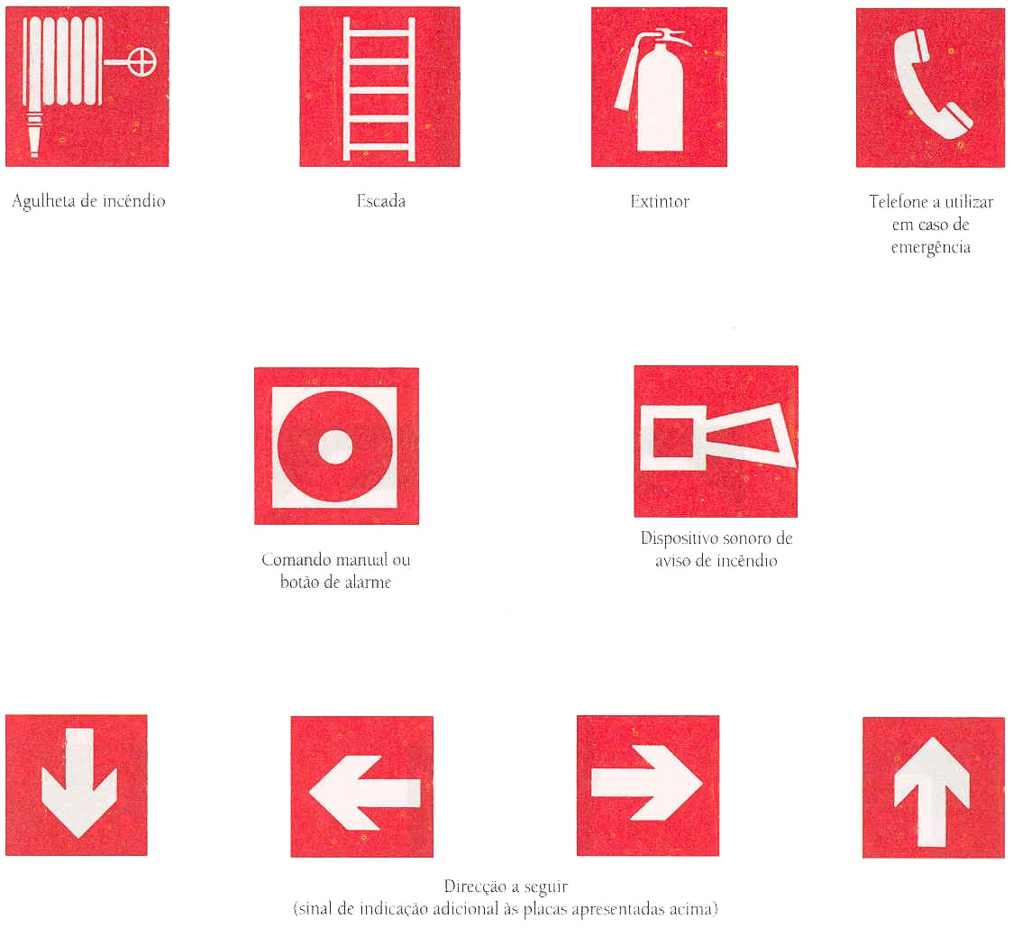

Direction to take  
(additional indication signal to the above signage)

Fire warning audible device

Manual control or alarm button

Emergency telephone

Fire extinguisher

Fire escape

Fire hose nozzles

**Figure 5.** Examples of firefighting equipment signs. White pictogram and red background. *in* Miguel, Alberto Sérgio S. R. (2000), Manual de Higiene e Segurança do Trabalho, Porto, Porto Editora, 5th Edition

# Accidents

Considering that laboratories are hazardous locations, knowledge of and compliance with safety rules may not be enough to prevent accidents from occurring.

* **For any job-related accident please fill in the Reporting and Qualification form, which is available on the NSHS and DRH webpages for registration and analysis by NSHS.**

## In the event of an accident that endangers physical integrity of individuals

* In the event of an accident, where possible, do not move the injured person until medical emergency services arrive, except where strictly necessary, when he or she runs even greater risk of inhalation or prolonged skin exposure. Nevertheless, small accidents (wounds/lacerations or burn injuries) must be treated immediately according to basic instructions mentioned in Annex II – Accidents that may occur in the laboratory and procedures to be adopted.
* Safety equipment mentioned in paragraph 3.1. is deployed in all laboratories or in their vicinity. Users must always make sure of where it is located and where it is working properly.
* Where first aid kits are used, fill in the registration form and inform the person in charge that the kits products have been used for replenishment.
* Where the seriousness of the accident justifies, please call the European Emergency Line (112) (see Annex III – ).
* Other emergency contacts are given in Chapter 2.
* If the victim is exposed directly to chemical products, please call the Anti-poison Information Centre (808 250 143) and ask for information on how to act correctly.
* IST, ADIST and IST-ID have personal accident insurance, which cover students, ADIST employees and researchers and that must be claimed, if needed. For further information, you should call the respective entities. Additional information to this manual should be displayed in the laboratory or include the number of insurance policies in an annex.
* In the event of an accident, IST covers the expenses involved in individual civil service employment contracts. Therefore, all expense receipts (travel and treatment) should be requested. To be considered as accident at work, injured persons should report the accident in writing (in a specific form for the purpose: Participação e Qualificação do Acidente em Serviço.doc) and take it to hospital: Boletim de Acompanhamento Médico.doc, which are both available on the NSHS and DRH webpage. For further information please the NSHS webpage: <http://nshs.tecnico.ulisboa.pt/acidentes-de-trabalho/>.

## In the event of an accident that endangers integrity of the building and/or its occupants

If a large-scale accident occurs that endangers integrity of the building and/or its occupants, for example, a fire, a serious chemical spill, a hazardous gas explosion or release, the entire building must be evacuated: (see also Annex IV – )

* Sound the alarm (press a fire button or contact the Security Centre/Reception);
* Contact the European Emergency Number 112;
* Contact the Security Centre/Reception (to ask for help, please call 112 or to inform emergency authorities that will enter the campus and need to go to site);
* Evacuate the building.

**Note:** As far as the South Tower at the Alameda *Campus* is concerned, the expression “sound the alarm”, in the event of a chemical spill, means that the reception button must be triggered so that the venting remains on.

# Fire

Fire is the most common accident in buildings. As such, there is a lot of concern with these events because the development of a fire is usually very fast and puts human lives, goods and buildings at risk.

In most cases, gases and fumes are the people’s major enemy, as they expand very rapidly from the bottom of buildings, irritating the breathing ways and making it difficult to see.

Therefore, fire prevention is extremely important, which depends on the existence of a fire detection system, fire-fighting equipment and, finally yet importantly, compliance with safety rules that prevent fires from occurring.

## Classes of fire and extinguishing agents

Fire is an exothermal reaction (releases heat) between combustible material and an oxidizing agent. For a fire to take place, it is necessary to combine three elements: fuel, oxygen and heat.

|  |
| --- |
| Resultado de imagem para fire triangle  Figure 6. Fire triangle. |

To put out a fire it is necessary to have control of one of the Fire Triangle sides, i.e.:

* by suppression of fuel – removing the combustible material nearby or isolating the object in flame;
* by muffling a fire – preventing oxygen contact with the flame material;
* by cooling – making the fuel temperature to drop.

Nevertheless, if the combustion has already begun, it is also possible to put it out by inhibition, which is part of the chain reaction by using chemical powder.

In a laboratory or in its vicinity, there are portable fire extinguishers, which are appropriate to the type of fire that may emerge (see Table 1). In most cases, it is possible to put out a fire if you have prior knowledge of the type of fire you are dealing with.

Table 1. Classes of fire.

|  |  |  |  |
| --- | --- | --- | --- |
| **Class** | **Type of Combustion** | **Types of fuel material** | **Symbol** |
| A | Combustion of solid materials, usually of organic nature, in which combustion is normally done by ember formation. | Wood, coal, paper, fabric, ... | Classe de Fogo A |
| B | Combustion of liquids or liquefiable solids. | Lube oils, petrol, oil, petroleum, alcohol, ink, wax, plastic, paraffin, varnish, ... | Classe de Fogo B |
| C | Combustion of different types of gas. | Butane, propane, natural gas, acetylene, hydrogen,... | Classe de Fogo C |
| D | Combustion of light metal and other metals. | Sodium, magnesium, titanium, aluminium, lithium, uranium,... | Classe de Fogo D |
| F | Combustion involving cooking products. | Animal and vegetable fats and oils | Classe de Fogo F |

Table 2 shows different forms of extinguishing and dealing with fire.

Table 2. Forms of extinguishing and dealing with fire. From the book entitled “Manual de segurança contra incêndios em edifícios”, Escola Nacional de Bombeiros, 1st edition

|  |  |  |
| --- | --- | --- |
| **Extinction** | **How to act** | |
| Water | Cooling | 1 |
| CO2 | Muffling | 3 |
| Foam |
| Fire blanket |
| Sand |
| Chemical powder  (Halon) | Inhibition | 4 |
| Scarcity (Fuel deprivation) | Fuel scarcity | 2 |

Table 3 shows in which class of fire extinguishing agents may be used.

Table 3. Extinguishing agent to be used depending on the class of fire (Adapted from the Manual of Malfunction Limitation School).

|  |  |  |  |  |
| --- | --- | --- | --- | --- |
| **Extinguishing Agent** | **Class of fire** | | | |
| A | B | C | D |
| Jet water | **✓** | **🗶** | **🗶** | **🗶** |
| Water-spraying | **✓** | **⚫** | **🗶** | **🗶** |
| Carbon Dioxide (CO2) | **🗶** | **⚫** | **⚫** | **🗶** |
| Dry Chemical Powder (ABC class) | 🞧 | 🞧 | 🞧 | **🗶** |
| Dry Chemical Powder (BC Class) | **🗶** | **✓** | 🞧 | **🗶** |
| Special Chemical Powder (D Class) | **🗶** | **🗶** | **🗶** | **⚫** |
| Foam | **⚫** | 🞧 | **🗶** | **🗶** |
| Halon (restricted use) | **⚫** | 🞧 | 🞧 | **🗶** |
| **✓ Very Good;** 🞧 **Good; ⚫Sufficient; 🗶 Insufficient** | | | | |

Annex IV – shows some rules that are mandatory and how to use extinguishers.

# Chemical Products: Risk and Safety

Handling chemicals safely in laboratories means that there is an obligation to comply with previously mentioned rules, particularly in identifying risks/dangers involving each product. Physical and chemical properties are intrinsic characteristics of chemical agents with potential danger. Therefore, the intrinsic risk to a chemical product is the likelihood that said potential risk has to occur in use or exposure conditions.

Information sources on the chemical dangers/risks include: package labels (in particular the danger-indicating pictograms, the signal word, the danger warnings and safety advice), safety data sheets (SDS or MSDS) supplied by the manufacturers, scientific and technical literature, published guides and legislation.

## Identification/labelling and warning signals/symbols

**A chemical substance or product must be correctly identified**, because only by doing this can we identify the hazards and risks to which the user may be subject in handling and, therefore, preventing the accident.

All products must be correctly identified and comply with current regulations and legislation. Labels should therefore carry the pictograms and information shown in Figure 7. Whenever any label becomes unreadable, it is critical to reproduce the whole of information and place it on the packaging.

|  |
| --- |
| EC N.  Additional information  Nominal quantity  Danger warnings and safety recommendations  Danger  Easily flammable liquid and vapour. Cause serious eye irritation. May cause drowsiness and dizziness. Keep away from heat/spark/open flame hot surfaces – Do not smoke. Use protection gloves/goggles. IN CONTACT WITH THE EYES: rinse thoroughly with water for several minutes. If you use contact lenses, remove them, if possible. Keep on rinsing. Store in a well ventilated place. Keep the receptacle tightly closed.  May cause dry or cracked skin by repeated exposure  Supplier name, address and telephone number  Signal Word  **Acetone**  Chemical name and product identifier  Pictograms |

Figure 7. Label example.

*In* http://www.act.gov.pt/(pt-PT)/crc/PublicacoesElectronicas/Documents/Folheto\_rotulos\_produtos\_quimicos.pdf

Table 4. Chemical hazard pictograms.

|  |  |  |  |  |
| --- | --- | --- | --- | --- |
| **Symbol** | **Meaning** | | | **Precautions** |
| C:\Users\pedrolimaduarte\Desktop\Manuais Seg Lab\explos.gif | Explosive | Physical hazards | * Self-reactive substances; * Organic peroxides that may cause explosion under heat. | * Avoid shock, friction, sparks and heat. |
| C:\Users\pedrolimaduarte\Desktop\Manuais Seg Lab\rondflam.gif | Flame over circle | * Oxidizing substances that may cause or step up fires and explosions. | * Keep away from combustible substances. |
| C:\Users\pedrolimaduarte\Desktop\Manuais Seg Lab\flamme.gif | Flame | * Self-heating substances and mixtures; * Pyrophoric liquids and solids that may catch fire in contact with air; * Substances and mixtures that, in contact with water, emit flammable gases; * Self-reactive substances or organic peroxides that may cause fire under heat. | * Avoid contact with ignition sources (flames, heat, sparks,…); * Avoid formation of hazardous air/gas mixtures. |
| C:\Users\pedrolimaduarte\Desktop\Manuais Seg Lab\bottle.gif | Compressed gas | * Compressed gas, explosion risk under heat; * Cooled gas that may cause burns or cryogenic injuries; * Dissolved gases. | * Do not expose to heat or ignition sources; * Handle carefully, use PPE if necessary; |
| C:\Users\pedrolimaduarte\Desktop\Manuais Seg Lab\skull.gif | Toxic | Hazards to health | * Highly toxic substances in contact with skin and that may be fatal if inhaled or ingested. | * Avoid body contact and vapour inhalation. If an accident should occur, please call a doctor. |
| C:\Users\pedrolimaduarte\Desktop\Manuais Seg Lab\exclam.gif | Harmful | * Highly toxic (harmful); * Causes skin irritation and skin and eye irritation; * Causes irritation to breathing ways; * Narcotic. Causes drowsiness or dizziness. | * Avoid body contact and vapour inhalation. If an accident should occur, please call a doctor. |
| C:\Users\pedrolimaduarte\Desktop\Manuais Seg Lab\acid_red.gif | Corrosive | * Corrosive substance that may cause serious skin and eye burns. Also corrosive to metal. | * Do not breathe vapours and avoid skin and clothes contact. |
| C:\Users\pedrolimaduarte\Desktop\Manuais Seg Lab\silhouete.gif | Health hazard | * Carcinogenic substances; * Affects fertility and unborn child; * Causes mutations; * Respiratory sensitizer, may cause allergies, asthma or respiratory difficulties when inhaled; * Toxic to specific organs; * Aspiration hazard. May be fatal or harmful if swallowed or enters breath ways. | * Avoid body contact and vapour inhalation. If an accident should occur, please call a doctor. |
| C:\Users\pedrolimaduarte\Desktop\Manuais Seg Lab\Aquatic-pollut-red.gif | Environment hazard | Hazard to the environment | * Dangerous substances to the environment and that cause aquatic toxicity. | * These substances must not be released into the environment. Must be duly packed and subject to appropriate treatment. |

## Storage of chemical substances

Safe storage of chemical products is extremely important in order to avoid possible accidents. Appropriate facilities are needed along with adequate equipment and working habits. For the purpose, four key-elements are mandatory:

* An inventory of equipment available in a laboratory and a warehouse must be kept;
* All products must be duly labelled;
* Incompatible chemical products must be set apart;
* An adequate environment, including ventilation, lighting, temperature and adequate organization in shelves and equipment.

Storage of chemical products must comply with the rules listed below:

* Do not store incompatible chemical products together;
* Keep flammable products in approved safe packages and in cabinets intended for flammable products (keep in those cabinets flammable products only);
* Separate strong acids from concentrated solutions;
* Keep oxidants alone and, in particular, away from flammable solutions;
* Keep corrosive materials away from substances that may exhale, by contact, corrosive, toxic or flammable fumes;
* All products, in particular toxic, carcinogenic and teratogenic products must be stored in unbreakable receptacles and in restricted access areas;
* Separate chemical products according with the following categories:
  + Solids: oxidant/ flammable / water reactive/ others;
  + Liquids: acids/ bases/ oxidants/ flammable and combustible / perchloric;
  + Gases: Toxic/ oxidant and inert/ flammable;
* Inside a laboratory, reduce acquired and stored chemical products to a quantity that can be used in a reasonably short period of time;
* All products must be duly identified/labelled, with the label in a good condition and readable;
* Containers should not be too close to the shelf limit;
* Large receptacles which contain toxic, corrosive or flammable substances must be kept in places below eye level;
* Avoid product storage in workbenches and hottes;
* Do not store chemical products on the ground;
* Containers with acids and bases must be placed within retention basins, in a warehouse, which is also recommended inside laboratories;
* Volatile chemical substances must be stored in ventilated storage spaces and/or ventilated cabinets;
* Unstable and volatile materials must be stored in adequate fridges (fire-proof and with temperature control), as long as they are kept in duly sealed containers. Never store flammable solvents (ether, benzene) inside the fridge in open containers;
* Cooled samples must contain a label with information concerning the contents, owner and date of preparation. Fridges for samples must be adequate (fire-proof and with temperature control).

## Incompatible reactants

Keep away certain substances from contact with others with which they may react violently, which causes explosions or forms toxic or flammable products. As a result, and as mentioned in chapter 6.2, incompatible reactants must be stored in separate locations.

Annex V – shows some examples of incompatible chemical products (The given list is not exhaustive).

## Hazard Statements (H) e and Protective Statements (P)

In order to know potential hazards and risks attached to chemical products, as well as safety procedures for handling, storing and eliminating these products, it is necessary to use the information given on the labels and safety data sheets. This information is given by pictograms, signal words and also by warning and hazard statements (H) and protective statements (P).

Hazard statements (H) describe the nature of hazards of a substance or a mixture. Hazard code numbers (H) are usually indicated in the safety datat sheet. They could also appear on the label of some chemical products, although it is not mandatory.

Hazard code numbers:

* H200-H299 – physical hazards;
* H300-H399 – health hazards;
* H400-H499 – environment hazards.

Protective statements (P) describe the recommended measures to mitigate or prevent adverse effects, emergency response measures such as first aid, safety storage and disposal. The label usually should not contain more than six P recommendations, but additional P recommendations may be included in the safety data sheet (SDS/MSDS) of the chemical product.

Protective statements code numbers:

* P100 - General;
* P200 - Prevention;
* P300 - Response;
* P400 - Storage;
* P500 - Disposal.

Annex VI – Hazard Statements (H statements) and Precautionary Statements (P statements) shows Hazard Statements (H) and Protective Statements (P).

## Safety Data Sheets (SDS or MSDS)

Safety data sheets (SDS), or MSDS (Material Safety Data Sheet), are documents elaborated by manufacturers or suppliers of chemical products which contain detailed information on their physical and chemical properties, allowing for a better understanding of risks, safety in use and answers, if an accident should occur.

It is critical do write safety data sheets in accordance with Annex II of REACH Regulations. As such, it is mandatory to observe all 16 sections given in Table 5.

Table 5. SDS Sections. Adapted from: http://percentil.com.pt/resources/NT%20Fichas%20Dados%20Seguran%C3%A7a.pdf

|  |  |  |
| --- | --- | --- |
| **Section** | | **Subsection** |
| 1 | Identification of substance/mixture and firm/company | * Product identifier * Uses deemed relevant of the substance or mixture and uses advised against * Supplier identification of the safety data sheet * Emergency telephone contacts |
| 2 | Identification of hazards | * Classification of the substance or mixture * Label elements * Other hazards |
| 3 | Composition/information on components | * Substances * Mixtures |
| 4 | First aid | * Description of first aid measures * Most important symptoms and effects, not acute and delayed * Indications regarding urgent medical care and special treatment needed |
| 5 | Fire-fighting measures | * Extinguishing resources * Special hazards stemming from substance or mixture * Recommendations for fire-fighting personnel |
| 6 | Measures to be adopted in the event of accidental spills | * Individual precautions, protection equipment and emergency procedures * Environmental protections * Confinement and cleaning methods and material * Reference to other sections |
| 7 | Handling and storage | * Precautions for safety handling * Safety storage conditions, including any incompatibilities * Specific-end uses |
| 8 | Exposure control/Individual protection | * Control parameters * Exposure control |
| 9 | Physical and chemical properties | * Information about basic physical and chemical properties * Other information |
| 10 | Stability and reactivity | * Reactivity * Chemical stability * Possibility of hazardous reaction * Conditions to avoid * Incompatible materials * Hazardous decomposition materials |
| 11 | Toxicological information | * Information about toxicological effects |
| 12 | Ecological information | * Toxicity * Persistence and degradability * Bio-accumulation potential * Mobility in soil * PBT and mPmB evaluation outcomes * Other adverse effects |
| 13 | Disposal considerations | * Waste treatment methods |
| 14 | Shipping information | * UN Number * Official UN shipping name * Hazard classes for shipping purposes * Packaging group * Environmental hazardous * Specific user precautions * Bulk transport in compliance with Annex II of MARPOL Convention and IBC Code |
| 15 | Information on regulations | * Specific regulations/legislation for substance or mixture in terms of health, safety and environment * Chemical safety evaluation |
| 16 | Other information | - |

In addition to this manual, each laboratory must have its own SDS of the chemical products used for reference. Sections 4, 5 and 6 of these SDS should be highlighted (for instance, fluorescent emphasis recommended) so that, in the event of need, they are easily analysed.

## Compressed gases

Compressed gases may be broadly split into three groups: liquefied gases, Non-liquefied gases and dissolved gases:

* Liquefied gases: It is a partly liquefied gas at 21ºC, at bottle load pressure. Propane and Carbon Dioxide are examples of liquefied compressed gases.
* Non-liquefied gases: It is a gas that is fully kept in gaseous state at 21ºC, at bottle pressure. Oxygen, nitrogen, helium, argon and hydrogen are examples of non-liquefied gases.
* Dissolved gases: It is a gas that is kept dissolved in a solvent. The sole example of common use is acetylene, generally dissolved in acetone, given that it is unstable in the absence of a solvent (it is spontaneously flammable in contact with air at slightly higher pressures than ambient temperature). Acetylene cylinders contain a porous matter impregnated with acetone and in which acetylene is dissolved.

## Potential hazardous associated with compressed gases

* Pressure: Failure probability of gas cylinders is extremely small if handled correctly. Nevertheless, they can fail due to wrong filling techniques, corrosion or fire. All compressed gases must be considered potentially dangerous due to high pressure they may go through.
* Flammability: Hydrogen, acetylene, methane are examples of flammable gases.
* Oxidants: Oxidant gases are those that cause or speed up combustin of flammable materials. Oxygen, nitrous oxide and chlorine are examples of oxidant gases.
* Asphyxia: Asphyxia is the main hazard associated with inert gases. As they are completely odourless and unseen it is possible that a leak has gone undetected for an extended interval. Examples of inert gases of common use are nitrogen and argon.
* Corrosion: Corrosive gases may attack metals and affect skin quickly. Corrosive gases, such as NH3, HCl ou HCN, may attack fire-protection clothing.
* Toxicity: Gas toxicity varies between extreme toxicity (causing death or serious damage after brief contact) and light toxicity (causing irritation). Hydrogen cyanide and carbon dioxide are an example. Toxic gases, such as Cl2 ou NO, cause poisoning but symptoms may not be immediate.
* Burns: Contact with cryogenic fluids (liquefied gases) with skin burns.

## Identification of gases cylinders by colours

The colour code of gas cylinders is based on the European norm EN 1089-3, which sets up a colour identification system of the risk associated with the gas cylinder content. The main colours are:

* Yellow: Toxic and/or corrosive
* Red: Flammable
* Blue: Oxidant
* Green: Inert

Gases with specific colours are nitrogen, oxygen, argon, helium, carbon dioxide, hydrogen, acetylene.

Table 6 shows the cylinder colour coding and some gases.

Table 6. Gas cylinder colour coding (Adapted from: http://www.airliquidemedicinal.es/file/otherelement/pj/cambio%20de%20color%20botellas-alm%20pdf180299.pdf)

|  |  |
| --- | --- |
| **Gas** | **Colour** |
| Acetylene | Reddish-brown |
| Ammonia | Yellow |
| CO2 | Grey |
| Argon | Dark green |
| Ar | Green |
| N2 | Black |
| O2 | White |
| H2 | Red |
| He | Brown |

## Gas storage and use

It is critical to observe some rules, which apply to cylinder storage and use, as follows:

* Store the least possible number of gas cylinders;
* Store gases in a fresh, aired place with restricted access;
* Fix all bottles to the wall through a chain or otherwise. Small cylinders must be also fixed or tied otherwise. Small bottles must also be fixed or tied otherwise;
* Remove seal when using only;
* Use equipment recommended by supplier only. Use materials compatible with gas;
* Separate empty cylinders from full ones;
* Handle empty cylinders as if they were full. An empty cylinder is never completely empty;
* Never use oil or other grease in connections or equipment for gases;
* Never use adapters;
* Use an effective leak detection system;
* Valves must always be closed, even for empty cylinders;
* Never take the cylinder tap off;
* Valves must only be manoeuvered manually, never use keys;
* Never retighten a connection under pressure;
* Check whether there are leaks where the cylinder and the pressure regulator join. For the purpose, apply a water and soap solution with a brush in joints to be checked;
* By opening a cylinder the user must always be outside the ejection trajectory of the hand reducer device;
* At the end of the work session, you should close the cylinder valve, open the valves of the hand reducer device and release pressure and then close all valves again;
* Cylinders must be stored for the strictly necessary time, by complying with the validity deadline for the respective gas and/or maximum period of 10 years (at the end of which an hydraulic test is mandatory);
* When using gases the respective safety data sheets must always be consulted.

The use of gas networks in laboratories is also subject to compliance with rules, many of which are mentioned above. Nevertheless, in some cases such as the use of city gas, it is necessary to:

* **Check for leaks periodically (i.e. every 3 months), in particular in flexible connections and gas burners. For the purpose, apply a water and soap solution with a brush in joints to be checked;**
* Always close the valves after use;
* Use an effective leak detection system.

Whenever the gas leak-detection systems sound the alarm, the work must stop immediately until the problem is solved, be it a leak or a false alarm. The work should only be resumed if the leak-detection system becomes operational.

Liquefied gases (cryogenic fluids) are characterized by extremely low temperatures and by a high capacity of expansion in volume when they change their status, from liquid to gaseous. One of the most used cryogenic fluids is liquid nitrogen.

Some rules in the use of liquid nitrogen are mandatory, in addition to those already mentioned in this manual:

* Check the safety data sheet;
* Use Personal Protective Equipment (dry clothes covering the whole body, closed shoes, protective gloves, goggles);
* Store and use in well ventilated places;
* Do not wear rings, watches or any other ornaments that promote a more extended contact of cryogenic fluids with skin;
* Use adequate and easy-to-remove gloves;
* Hands must not be submerged in any case whatsoever in liquid nitrogen even they are protected;
* Only use adequate material and containers: stainless steel, copper, aluminum, brass, dacron, teflon and nylon. Materials such as wood, plastic and rubber are not adequate;
* Do not place liquid nitrogen containers near surces of ignition because exposure to fire may cause containers to break and/or explode;
* Liquid nitrogen with a bluish colour is a sign of contamination is need to be replaced. The contaminated material is hazardous and potentially explosive.

# Physical hazards

Taking into consideration the type of work/research, some laboratories do not have chemical hazards, in particular physical ones.

Physical hazards are agents/factors that are present in the working environment, such as radiation, electricity, extreme temperatures, noise, equipment or unsafe/inadequate lifting devices, slippery floor and deficiencies in the workplace, which are a real or potential cause of accident, injuries, tension or discomfort.

The user must always play an active role in examining and checking for safe conditions of the equipment and/or tools, and of the working processes so that the activity be carried out safely, while identifying existing risks and reporting corrective measures.

Table 7 shows some physical risks and respective corrective measures.

Table 7. Physical hazards and respective protective measures.

|  |  |  |
| --- | --- | --- |
| **Hazards** | **Dangers** | **Protective measures** |
| Electrical | * Direct contact * Indirect contact | * Dot not use equipment with damaged cables; * Do not use facilities or electrical equipment under voltages and intensities above those prescribed; * Use safely three-way plugs and extensions of electrical cables; * Use tools with correct insulation for the work to be carried out; * Avoid electrical cable overheating. |
| Skeletal-Muscle or Mechanical | * Incorrect posture * Too much effort * Inadequate movements * Falls from a height (different levels) * Same-level falls * Falling objects * Collision with structures * Handling cutting objects * Contact with moving elements * Shearing | * Adopt correct posture * Use technical aids (mechanical means) for load manual transport; * Use anti-slippery shoes with toecap and sole protection; * Do not remove protective elements from machinery and equipment; * Use mechanical protective gloves; * Use protection goggles; * Organisation of the workspace; * Ensure that display screen equipment is correctly arranged. |
| Noise | * Prolonged exposure without Personal Protective Equipment may: * Harm hearing organs; * Disturb communication; * Cause irritation; * Reduce work performance. | * Use ear protectors/tips where there is noise exposure. |
| Non-ionising radiation | * Laser * Electromagnetic field * Cathode rays * Ultraviolet | * Use protection goggles/masks (for e.g. welding). |

# Radioisotopes

Radioisotopes (or radioactive isotopes) are isotopes of elements with unstable nuclear structure, which naturally tend to transform into other with greater stability, issuing particles and/or electromagnetic radiation.

## Handling radioisotopes

Before starting any activity that involves handling radioisotopes, everyone must receive individual training in handling radioactive sources and, in particular, in operations with radioisotopes.

Before any operation, bearing in mind the properties of each isotope:

* Identification of radioisotope;
* Type of emission: radiation alfa, beta and/or gama;
* Period of semidesintegration: T1/2 (expressed in seconds, minutes, day, year);
* Activity or number of desintegrations per second (Becquerel, Bq)
* Average energy of emitted radiation (electron-volt, eV).

Bear in mind practical aspects of radiological protection when handling isotopes:

* External irradiation – exposure to a source of radiation outside the body;
* Internal irradiation – exposure to a source of radiation incorporated by ingestion, inhalation or adsorption;
* Contamination – undesired propagation of radiactive material.

In terms of external radiation exposure, it is mandatory to consider radiological protection rules, such as:

* Expected time of exposure;
* Distance between the source of radiation and who is in charge of handling;
* Protection devices to reduce the source activity, for example protection barriers, container, Personal Protective Equipment (lead apron, goggles);
* Whole-body dosimeter (for example, TLD);
* Any edge dosimeter.

As regards internal radiation, it is mandatory to bear in mind radiological protection rules, such as:

* Use of laboratory coats, closed shoes, Personal Protective Equipment (lead apron, gloves, goggles, mask…);
* Do not eat, drink or smoke;
* Do not inhale solutions containing volatile radioactive species;
* If your are wounded, do not manipulate radioisotopes;
* If you are pregnant do not operate radioisotopes.

The person who will be in charge of handling the radioisotope must comply with general radiological protection procedures and take necessary precautions to ensure that he/she or his fellow workers have been exposed ALARA – As Low As Reasonably Achievable.

## Preventive rules to reduce risks associated with radioisotope handling

## Safety in the facility

* Handling radioisotopes must be carried out in duly identified places for the purpose in accordance with the radioisotope characteristics and the type of work to be carried out;
* Working areas must be clearly identified. Access to premises must be restricted to authorised personnel as much as possible;
* Laboratory and cleaning equipment and machinery must not be used outside the premises;
* Adequate protection barriers to handled activity, to time exposure and distance to source, as well as to radioisotope radiotoxicity and other properties;
* There should be adequate monitors to detect any contamination in the vicinity of the handling isotope areas;
* There should be emergncy procedures which cover contamination situations of the laboratory and/or works that handle the radioisotopes;

## Individual safety

In addition to the basic safety rules mentined in Chapter **Error! Reference source not found.**, it is:

* Mandatory to use a whole-body dosimeter;
* Mandatory to use a tip dosimeter where there a risk of significant hand exposure;
* Forbidden to keep food, beverages or personal objects in the working areas;
* Forbidden to handle radioactive material by workers with wounded hands, even wearing gloves;
* At the end of the working session, laboratory coats, lead aprons and protection goggles should be left ath the laboratory entrance. Protection shoes and disposable gloves must be deposited in adequate bins that exist in the laboratory for further disposal;
* At the end of the working session, user monitoring must be carried out and the respective recording of outcomes;
* Do not take your mobile phone into the laboratory. Take it inside a plastic bag, if necessary.

## Safety during handling

* Operations with radioactive material must be prepared upfront in order to limit the time of exposure and avoid material dispersion. Procedures and material should be checked before handling;
* The working area must be prepared by reducing the material to the least possible;
* They must be placed the nearest possible of the radioactive source of the protection barriers adequate to the radiation nature;
* Work in decks coated with easily washable and non porous material (for example, deck made of stainless steel; decks made of marble are not acceptable for this type of work);
* Radioactive material must be handled in a properly sized deck for the work to be done and wrapped properly in absorbing material;
* Where there should be a risk of scattering liquid material, absorbing material should be placed around the working deck;
* Disposable material should be used where possible. Non disposable laboratory material should be allocated for work of this nature only;
* Clamps should be preferably used when handling;
* Containers with radioactive material must be identified legibly.

## After radioisotope handling

* Clean the working area immediately after the work has been done;
* Segregate radioactive waste from non-radiative waste;
* Dispose of non-radiactive waste and segregate radioactive waste in accordance with internal waste management rules;
* Keep all radioactive solutions and composites in well identified containers with the isotope identification, activity, date and use time;
* All non disposable material and the working area must be monitored with an adequate radiation monitor. If the material is contaminated, it should be left decaying in a duly identified container and at an apporpirate location or be decontaminated with a decontaminant solution;
* Also check for contamination of decks and floor;
* Measured values must be recorded and compared with basic values, which must be measured regularly by the person in charge of the laboratory;
* If the values found are much higher than the values usually measured in the laboratory, the user must inform the person in charge of the laboratory, who will take necessary action for decontamination;

## Radioactive waste management and storage

Control the amount of radioactive waste to the least:

* Separate non radioactive waste;
* Control “suspicious” waste.

Separate radioactive waste in accordance with the physical properties of radioisotopes (type of filling, decay, semi-disintegration period) and physical and chemical form (for example, volatile species) by using adequate containers for the purpose.

According to the semi-disintegration period of the radioisotope:

* Radioisitopes with long semi-desintegration periods;
* Radioisitopes with short semi-desintegration periods (T < 100 d).

In addition to the segregation by isotope, waste is also separated according to its nature:

* Solids non subject to putrefaction (gloves, paper, syringes without a needle, disposable plastics,...);
* Biological hazard solids;
* Aqueous solvents;
* Non-aqueous solvents;
* Biological sample suspensions;
* Glass material;
* Needles and cutting material.

It is mandatory to segregate, package and duly identify waste by radioisotope, date and nature.

# Biological Agents

Biological agents are microorganisms (any microbiological cellular or non-cellular entity with reproduction or genetic material transfer capacity - bacteria, viruses, fungi and parasites), including genetically modified agents, cell cultures and human endoparasites, which are likely to cause infections, allergies or intoxications. In accordance with legislation, biological agents are classified in four groups according to their degree of infection (Table 8).

Table 8. Classification of biological agents (DL 84/97, of 16 April).

|  |  |  |  |
| --- | --- | --- | --- |
| **Group** | **Hazard** | **Propagation hazard** | **Prophylactic or treatment means** |
| 1 | Highly unlikely to cause diseases in human beings | None | Unnecessary |
| 2 | May cause diseases in human beings and be dangerous for workers | Unlikely | Available, as a rule |
| 3 | May cause serious diseases in human beings and be a serious danger for workers | Likely | Available |
| 4 | Causes serious diseases in human beings and be a serious risk for workers | High | Not available |

Preventive measures to reduce risks associated with exposure to biological agents

* Establish adequate work procedures and use appropriate technical measures to avoid or minimize the release of biological agents;
* Observe hygiene rules: do not smoke, do not eat in the lab, always wash hands after handling biological material;
* Use adequate protective clothing;
* Correctly indicate the places (biological danger,…);
* Ensure that all protection equipment is kept in an appropriate place, checked and clean, if possible before and necessarily after each use, as well as repaired or replaced if it is defective or damaged;
* Have quick access to eye washes or antiseptics where appropriate;
* Set up procedures for collecting, handling and processing human or animal origin samples;
* Ensure the destruction, if necessary of contaminated protective clothing and PPE;
* Particular attention should be paid when using contaminated equipment and sharp objects, such as needles, which must not be placed in normal waste but rather in adequate containers;
* Ensure destruction/inactivation of contamintaed waste with biological agents.

# Personal Protective Equipment

Personal Protective Equipment (PPE) is designed for protecting workers of any hazards (proximity of chemical, physical, biological, electrical, radiological hazards …), considering their health or safety during the performance of certain activities.

PPE includes safety glasses, goggles, protection gloves, masks, protection suits, protection shoes, ear protectors …

It is mandatory to use PPE where existing hazards cannot be avoided or adequately limited by collective protection means or by organizational measures. Individual action, of which PPE is an example, is always taken as a last resort, because it acts on Man and is generally less effective.

Lab coats are mandatory because it contributes for greater protection of body and clothes.

Lab coats must be made of 100% of cotton. In order to protect skin, open shoes cannot be worn in the lab and the user must wear anti-slippery shoes.

Depending on intended activities, it is mandatory to use other type of equipment, such as masks and respiratory filters, goggles, safety suits and/or shoes with anti-slippery soles. Chemical product SDS provide information on how to handle those products and respective protections.

Table 9. Types of Personal Protective Equipment.

|  |  |  |  |
| --- | --- | --- | --- |
|  | **Head and skull:** Safety hats and head protection coverages  **Hazards:** Impacts, perforations, weather effects etc. |  | **Eyes:** Glasses, goggles, etc.  **Hazards:** Impacts, shrapnel, chips, liquid and dust projection, etc. |
|  | **Respiratory tract**: Protection masks for vapours, dust, etc.  **Hazards:** Dust, gases, vapours and harmful smoke. |  | **Ears:** Ear protection ear muffs.  **Hazards:** Noise |
|  | **Hands and harms:** Gloves, arm cuffs, fingerstalls, protection creams, etc.  **Hazards:** Skin irritation, electrical shock, burns, cuts, perforation, and abrasion. |  | **Legs and feet:** Toe-cap and steel midsole shoes and boots  **Hazards:** Cut, perforation, fall, impacts, pinching, cold and warm environments, etc. |
|  | **Trunk:** Overalls, laboratory coats, leather aprons, vests, coats, reflective clothing, etc.  **Hazards:** Sprinkles, electrical shock, burns, weather effects, exposure to high temperatures, exposure to low temperatures. |  | **Face:** Welding mask, goggles,  **hazards:** particle, liquid and dust projection, radiation, shrapnel, chips, etc. |

Bear in mind some aspects before selecting Personal Protective Equipment:

* The hazards to which the worker exposed;
* Your working conditions;
* The part of the body to be protected;
* The specific characteristics of the worker;
* Durability;
* The protection efect;
* Convenience;
* The possibility of being cleaned, among other aspects.

In the event of need you can also contact the NSHS to help you select PPE.

Prior to acquisition, PPE should:

* be selected according to the hazard to be protected;
* be comfortable, robust and light;
* bear EC marking;
* carry the manufacturer’s declaration of conformity, proof of compliance of equipment with the legally stipulated safety requirements for manufacture and sale;
* have an instruction manual, particularly in the form of information leaflet.

List of precautions you should take:

* PPE should be used only for the purpose it is intended;
* It is the users’ responsibility to ensure a good cleaning, hygiene and conservation of PPE;
* Those in leading positions should be immediated informed where PPE is damaged or unfilt for use and replaced;
* PPE should be clean and stored in a proper place after use and at the end of each shift;
* The period of validity of PPE and its components should be respected in accordance with the manufacturer’s instructions.

# Waste

Waste is generated from lab activity, which has a large impact on the environment. In an institution like IST, with numerous laboratories scattered around its various campuses, the production of waste such as heavy metals, halogenated and non-halogenated solvents, radioisotopes and infectious material has a great impact on the environment.

**In this context, it is not allowed to place chemical and biological waste on sewerage networks, not only due to the impact they have on the environment and health but also on infrastructure.**

Thus, IST has implemented a management system for different types of waste, (see Annex VII - NSHS 07/2011 Procedure – Waste Management at IST), which contains hazardous waste.

In addition to the above procedure, which is basically related to disposal of waste - whether through landfill or incineration - outside laboratories, some waste production norms must be complied with, in particular:

* Waste destination must be known thoroughly. The waste producer is responsible for the waste until it is delivered to licensed operators for treatment/disposal;
* Waste must be segregated according to its nature (solids/liquids).
* Waste must be collected in bags or proper containers/receptacles and identified (see label of the NSHS 07/2011 procedure);
* Waste resulting from common organic solvents must be separated in accordance with the NSHS 07/2011 procedure (separating in particular halogenated from non-halogenated solvents), and collected in suitably durable containers, supplied by NSHS;
* All receptacles/containers/bins with waste must be duly identified (see label of NSHS 07/2011 procedure);
* Cutting or perforating waste must not be thrown out with regular waste but in adequate receptacles;
* Biological waste must be neutralized/inactivated by autoclaving or bleaching;
* Inactive biological waste cannot be sent for disposal through hazardous waste signalled as biological hazard;
* Aqueous waste, without special hazard characteristics, must be neutralised before being sent to the public treatment network;
* Radioactive waste must comply with the guidelines mentioned in chapter 8.3.

# Bibliography

* http://www.isa.utl.pt/cef/ForEcoGen/Imagens/Armazenamento.pdf
* http://www.act.gov.pt/(pt-PT)/crc/PublicacoesElectronicas/Documents/Folheto\_rotulos\_produtos\_quimicos.pdf
* http://www.beswic.be/pt/faq/dangerous-substances-clp-reach/what-are-the-p-codes-on-the-safety-data-sheet
* http://www.beswic.be/pt/faq/dangerous-substances-clp-reach/what-are-the-h-codes-and-how-can-i-compare-them-to-the-familiar-r-phrases
* http://ec.europa.eu/enterprise/sectors/chemicals/files/ghs/signalwords\_hs\_ps\_en.xls
* http://echa.europa.eu/
* http://www.apambiente.pt/index.php?ref=16&subref=85
* http://percentil.com.pt/resources/NT%20Fichas%20Dados%20Seguran%C3%A7a.pdf
* http://www.airliquidemedicinal.es/file/otherelement/pj/cambio%20de%20color%20botellas-alm%20pdf180299.pdf
* Manual de Segurança em Laboratórios do Departamento de Química e Bioquímica, 2005, Faculdade de Ciências da Universidade de Lisboa
* Guia de Segurança no laboratório de química, 2006, Departamento de Química, Faculdade de Ciências e Tecnologia da Universidade de Coimbra
* Manual de Boas Práticas Laboratoriais, 2008, Centro de conservação e protecção do ambiente, Universidade dos Açores,
* Guia de segurança, Departamento de Química, Universidade de Aveiro
* Miguel, Alberto Sérgio S. R., 2000, Manual de Higiene e Segurança do Trabalho, 5.ª Edição, Porto Editora, Porto
* Castro, Carlos Ferreira de e Abrantes, José Barreira, Manual de segurança contra incêndios em edifícios, 1.ª edição, Escola Nacional de Bombeiros
* Cabral, Fernando et al, 2000, Higiene, Segurança, Saúde e Prevenção de Acidentes de Trabalho, Verlag Dashofer, Lisboa
* Pereira, Maria Manuela Araújo, Manual de Segurança dos Laboratórios do Departamento de Química, Universidade Nova de Lisboa - Faculdade de Ciências e Tecnologia da Universidade Nova de Lisboa
* Control of Risks in Work with Biological Agents, Part 2 Laboratory Work, International Section of the International Social Security Association (ISSA) for the Prevention of Occupational Risks in the Chemical Industry

The information concerning chapter 8 - Radioisotopes was provided by João Alves and Lurdes Gano of the *Campus* Tecnológico e Nuclear.

# Annex I – Reading register of the laboratory safety manual

**Use of IST Laboratories**

I \_\_\_\_\_\_\_\_\_\_\_\_\_\_\_\_\_\_\_\_\_\_\_\_\_\_\_\_\_\_\_\_\_\_\_\_\_\_\_\_\_\_\_\_\_\_\_\_\_\_\_\_\_\_\_\_\_\_\_\_\_\_\_\_\_\_\_\_\_\_\_\_\_\_\_\_, n.º mec/ist-id \_\_\_\_\_\_\_\_\_\_\_\_\_\_\_\_\_\_.

1. I declare that I have become aware of the existence of the Laboratory Safety Manual, whose basic model is available on the website: <http://nshs.tecnico.ulisboa.pt/seguranca-em-laboratorios/>;
2. Declare that I have read the Laboratory Safety Manual and understood the whole of its contents, in particular the rules of conduct, the terms of use as well as all safety rules contained therein.
3. Undertake to comply with all rules, indications and methodologies defined in the “Laboratory Safety Manual”, and to ensure that they are complied with.
4. Understand and accept that by failing to comply in part or in full with the rules, indications or methodologies mentioned above and contained in the “Laboratory Safety Manual” I can be prevented from entering the IST laboratories for an undefined period, which will be determined by the Department Head and Person-charge of Security.

Lisbon, \_\_\_\_\_\_ de \_\_\_\_\_\_\_\_\_\_\_\_\_\_\_\_\_\_\_ de 20\_\_\_\_

Signed by IST User: \_\_\_\_\_\_\_\_\_\_\_\_\_\_\_\_\_\_\_\_\_\_\_\_\_\_\_\_\_\_\_\_\_\_\_\_\_\_\_\_\_\_\_\_\_\_\_\_\_\_\_\_\_\_\_

Received (Resp. for Security): \_\_\_\_\_\_\_\_\_\_\_\_\_\_\_\_\_\_\_\_\_\_\_\_\_\_\_\_\_\_\_\_\_\_\_\_\_\_\_\_\_\_\_\_\_\_\_

# Annex II – Accidents that may occur in the laboratory and procedures to be adopted.

|  |  |
| --- | --- |
| **Type of Accident** | **Procedure** |
| **Wounds** | * If it is not a deep wound, let it bleed for a few seconds; * Remove small strange bodies. Deeply stuck objects should not be removed; * Wash the wound embedded with saline solution; * Disinfect with antiseptic; * Protect with a sterilised gauze. Cover with a patch or a bandage or put on a sticking plaster. |
| **Deep blow** | * Call for help; * Stop or reduce the bleeding by applying pressure on the wound. If it is a large wound or contains strange bodies, apply pressure above the cut surface, not more than 5 minutes; * Refer to urgent medical assistance. |
| **Small burns** | * Wash abundantly with water; * Apply fat gauze available in the first aid kit. |
| **Large burns** | * Call for help; * Wash abundantly the affected area with water; * Refer to urgent medical assistance. |
| **Chemical burns (ocular)** | * Identify the product that caused the injury * Wash eyes with open eyelids, with saline solution or in the eyewash unit; * Cover eye without pressing and refer to urgent medical assistance. |
| **Chemical burns (skin)** | * Identify the product that caused the injury * Rinse abundantly the affected area with water; * Apply fat gauze existing in the first aid kit.   **Note:** There are exceptions to this rule. With some acids or bases, it is convenient to wash your hands with basic or acid solutions as the case may be. Check when preparing the work through the FDS.   * Acids: wash with NA2 CO3 at 5%; * Bases: wash with acetic acid at 5% |
| **Inhalation of toxic substances** | * Identify the product that caused the intoxication; * Remove the injured person from accident scene; * If there is any inconsistency, please put the injured person in the recovery position (face-down position); * Contact the Poison Centre to get information on how to act. |
| **Faint** | * If you feel you are going to faint, please call for help immediately in order to avoid injuries as a result of your fall; * Refer to urgent medical assistance. |
| **Projection of chemical products into body or clothes** | * Call for help; * Get away from accident scene; * Take off your clothes; * Rinse abundantly body with water for 10 to 15min (emergency shower). |

|  |  |
| --- | --- |
| **Type of Accident** | **Procedure** |
| **Projection of chemical products into eye** | * Call for help; * If you are wearing glasses, please do not take them off. Rinse immediately your face in the eyewash facility. Take off your glasses. Wash your face again. |
| **Broken glass** | * Never touch the glass with your fingers; * Sweep the broken glass to a receptacle with the help of a shovel or paper towels. |
| **Small chemical spill** | * Clean the spillage with paper towels and place them in a receptacle for the purpose; * Wash the spill area, ensuring that the entire chemical product has been removed. |
| **Major chemical spill** | * Notify everyone present; * If it is possible, please use spillage absorption kits; * Place absorbents in a receptacle for the purpose and identify them; * Wash the accident scene; * Where it is impossible to control the spillage, please call for specialised help (e.g.: Firefighters). |
| **Small confined fire outbreak** | * If a fire develops inside a receptacle; * Call for help; * Search for something that may be used as a lid or use the fire blanket. |
| **Small, non-confined fire outbreak** | * Call for help; * Use the fire extinguisher or the fire blanket. |
| **Major fire outbreak** | * Call for help; * If it is not possible to control the fire with extinguishers, please sound the building alarm (break the fire knob) and/or contact the IST safety central. * Evacuate the building. |
| **Burning clothes** | * Do not run, because it only increases fire; * Call for help; * Stop, get down on the ground and roll over yourself; * If there is help: Put out any flames over the injured person with a fire blanket or use the emergency shower. |
| **Electrical shock** | * Cut or interrupt the source of energy, but refrain from touching the victim; * Take the victim away from the electrical source that was causing the shock by using dry and non-electrically conductive materials such as wood (broom handle), plastic, thick cloths or rubber; * Call 112. |

# Annex III – Emergency Leaflet



Security, Hygiene and Health Unit  
Emergencies  
What to do in an emergency  
Version 2  
March 2015

# Annex IV – Fire Leaflet



Fire  
What to do in the event a fire should occur  
Version 1  
January 2014

Correctly extinguish the fire – fire extinguisher

* Turn your back to the wind;
* Direct the spray to the flame bottom;
* Operate several extinguishers simultaneously, not one at a time;
* Do not allow fire to run off or flow drop by drop from top to bottom;
* Ensure that the fire does not flare up again.
* Replace used extinguishers

# Annex V – Incompatible chemical products

|  |  |
| --- | --- |
| **Reactant** | **Incompatible substances** |
| Acetylene | Chlorine, bromine, fluorine, silver, copper, mercury and its derivatives |
| Acetone | Mixtures of nitric acid and concentrated sulphuric acid |
| Acetic acid | Chromic acid, nitric acid, hydroxyl composites, ethylene glycol, perchloric acid, peroxides, permanganates |
| Hydrocianic acid | Nitric acid, bases |
| Chromic acid and chromium trioxide | Acetic acid, camphor, glycerol, alcohols, other flammable liquids |
| Nitric acid (concentrated) | Acetic acid, acetone, alcohols, aniline, chromic acid, hydrocyanic acid, hydrogen sulphide, flammable liquids, flammable gases, copper, brass, heavy metals |
| Oxalic acid | Silver, mercury |
| Perchloric acid | Acetic acid, bismuth and bismuth alloys, paper, wood, fats, oils |
| Sulphuric acid | Water, chlorates, perchlorates, permanganates, carbonates |
| Ammonia | Mercury, chlorine, hypochlorite, iodine, bromine, hydrogen fluoride, salts of silver |
| Aniline | Nitric acid, peroxides |
| Azides | Acids |
| Bromine | Ammonia, acetylene, butadiene, butane, methane, propane (or other gaseous hydrocarbons), hydrogen, benzene, finely divided metals |
| Activated charcoal | Hypochlorite, all oxidizing agents |
| Hydrogen cyanide | Nitric acid, bases |
| Chlorates | Salts of ammonia, acids, finely divided metals, Sulphur, finely divided organic substances or fuels |
| Chlorine | Ammonia, acetylene, butadiene, butane, methane, propane (or other petroleum gases), hydrogen, benzene, finely divided metals |
| Copper | Acetylene, hydrogen peroxide |
| Arsenic composites | Any reducing agent |
| Fluoride | Keep away from all substances |
| Hydrogen fluoride | Ammonia |
| Phosphorous (white) | Air, oxygen, bases, reducing agents |
| Hydrazine | Peroxides, nitric acid, all other oxidizing agents |
| Hydrocarbons | Fluorine, chlorine, bromine, chromic acid, peroxides |
| Sodium hydroxide and potassium | Water, acids |
| Hypochlorites | Acids, activated charcoal |
| Iodine | Acetylene, ammonia, hydrogen |
| Flammable liquids | Ammonium nitrate, chromic acid, hydrogen peroxide, nitric acid, sodium peroxide, halogen compounds |

|  |  |
| --- | --- |
| **Reactant** | **Incompatible substances** |
| Mercury | Acetylene, ammonia |
| Alkaline metals | Water, carbon dioxide, carbon tetrachloride, chlorate hydrocarbons chlorates, hydrogen |
| Ammonia nitrate | Acids, finely divided metals, flammable liquids, nitrites, sulphur, finely divide organic substances or fuels |
| Sodium nitrite | Ammonia nitrate, others salts of ammonia, acids |
| Calcium oxide | Water |
| Oxygen | Oils, fats, hydrogen, flammable materials |
| Perchlorates | Acetic anhydride, bismuth and bismuth alloys, alcohols, paper, woods, fats, oils, acids, fuels materials |
| Potassium permanganate | Glycerol, ethylene glycol, benzaldehyde, sulphuric acid |
| Hydrogen peroxide | Copper, chromium, iron, most of metals and their salts, alcohols, organic matter, aniline, nitromethane, flammable liquids, fuels substances |
| Sodium peroxide | All oxidizing substances like ethanol, methanol, glacial acetic acid, acetic anhydride, benzaldehyde, carbon disulphide, glycerol, ethylene glycol, ethyl acetate, Methyl acetate, furfural |
| Phosphorous pentoxide | Water |
| Potassium | Carbon tetrachloride, carbon dioxide, water |
| Silver | Acetylene, oxalic acid, tartaric acid, ammonia composites |
| Sodium | Carbon tetrachloride, carbon dioxide, water |
| Hydrogen sulphide | Fuming nitric acid, chromic acid, oxidizing gases, metal oxides |

# Annex VI – Hazard Statements (H statements) and Precautionary Statements (P statements)

(Adapted from: http://ec.europa.eu/enterprise/sectors/chemicals/files/ghs/signalwords\_hs\_ps\_en.xls)

**Hazard statements  (H statements)**

|  |  |
| --- | --- |
| H200 | Unstable explosives |
| H201 | Explosive; mass explosion hazard |
| H202 | Explosive, severe projection hazard. |
| H203 | Explosive; fire, blast or projection hazard. |
| H204 | Fire or projection hazard. |
| H205 | May mass explode in fire |
| H220 | Extremely flammable gas |
| H221 | Flammable gas |
| H222 | Extremely flammable aerosol |
| H223 | Flammable aerosol |
| H224 | Extremely flammable liquid and vapour |
| H225 | Highly flammable liquid and vapour |
| H226 | Flammable liquid and vapour |
| H228 | Flammable solid |
| H240 | Heating may cause an explosion |
| H241 | Heating may cause a fire or explosion |
| H242 | Heating may cause a fire |
| H250 | Catches fire spontaneously if exposed to air |
| H251 | Self-heating: may catch fire |
| H252 | Self-heating in large quantities; may catch fire |
| H260 | In contact with water releases flammable gases which may ignite spontaneously |
| H261 | In contact with water releases flammable gases. |
| H270 | May cause or intensify fire; oxidiser. |
| H271 | May cause fire or explosion; strong oxidiser. |
| H272 | May intensify fire; oxidiser. |
| H280 | Contains gas under pressure; may explode if heated |
| H281 | Contains refrigerated gas; may cause cryogenic burns or injury |
| H290 | May be corrosive to metals |
| H300 | Fatal if swallowed |
| H301 | Toxic if swallowed |
| H302 | Harmful if swallowed. |
| H304 | May be fatal if swallowed and enters airways |
| H310 | Fatal in contact with skin |
| H311 | Toxic in contact with skin |
| H312 | Harmful in contact with skin |
| H314 | Causes severe skin burns and eye damage |
| H315 | Causes skin irritation |
| H317 | May cause an allergic skin reaction |
| H318 | Causes serious eye damage |
| H319 | Causes serious eye irritation |
| H330 | Fatal if inhaled |
| H331 | Toxic if inhaled |
| H332 | Harmful if inhaled |
| H334 | May cause allergy or asthma symptoms or breathing difficulties if inhaled |
| H335 | May cause respiratory irritation |
| H336 | May cause drowsiness or dizziness |
| H340 | May cause genetic defects <*exposure cause the hazard*> |
| H341 | Suspected of causing genetic defects |
| H350 | May cause cancer |
| H351 | Suspected of causing cancer |
| H360 | May damage fertility or the unborn child |
| H361 | Suspected of damaging fertility or the unborn child |
| H362 | May cause harm to breast-fed children |
| H370 | Causes damage to organs |
| H371 | May cause damage to organs |
| H372 | Causes damage to organs through prolonged or repeated exposure <*exposure cause the hazard*> |
| H373 | May cause damage to organs through prolonged or repeated exposure <*exposure cause the hazard*> |
| H400 | Very toxic to aquatic life |
| H410 | Very toxic to aquatic life with long lasting effects |
| H411 | Toxic to aquatic life with long lasting effects |
| H412 | Harmful to aquatic life with long lasting effects |
| H413 | May cause long lasting harmful effects to aquatic life |
| EUH 001 | Explosive when dry |
| EUH 006 | Explosive with or without contact with air |
| EUH 014 | Reacts violently with water |
| EUH 018 | In use, may form flammable/explosive vapour-air mixture |
| EUH 019 | May form explosive peroxides |
| EUH 044 | Risk of explosion if heated under confinement |
| EUH 029 | Contact with water liberates toxic gas |
| EUH 031 | Contact with acids liberates toxic gas |
| EUH 032 | Contact with acids liberates very toxic gas |
| EUH 066 | Repeated exposure may cause skin dryness or cracking |
| EUH 070 | Toxic by eye contact |
| EUH 071 | Corrosive to the respiratory tract |
| EUH 059 | Hazardous to the ozone layer |
| EUH 201 | Contains lead. Should not be used on surfaces liable to be chewed or sucked by children |
| EUH 201A | Warning! Contains lead |
| EUH 202 | Cyanoacrylate. Danger. Bonds skin and eyes in seconds. Keep out of the reach of children |
| EUH 203 | Contains chromium (VI). May produce an allergic reaction |
| EUH 204 | Contains isocyanates. May produce an allergic reaction |
| EUH 205 | Contains epoxy constituents. May produce an allergic reaction |
| EUH 206 | Warning! Do not use together with other products. May release dangerous gases (chlorine) |
| EUH 207 | Warning! Contains cadmium. Dangerous fumes are formed during use. See information supplied by the manufacturer. Comply with the safety instructions |
| EUH 208 | Contains (name of sensitising substance). May produce an allergic reaction |
| EUH 209 | Can become highly flammable in use |
| EUH 209A | Can become flammable in use |
| EUH 210 | Safety data sheet available on request |
| EUH 401 | To avoid risks to human health and the environment, comply with the instructions for use |

**Precautionary statements (P statements)**

|  |  |
| --- | --- |
| P101 | If medical advice is needed, have product container or label at hand |
| P102 | Keep out of reach of children |
| P103 | Read label before use |
| P201 | Obtain special instructions before use |
| P202 | Do not handle until all safety precautions have been read and understood |
| P210 | Keep away from heat/sparks/open flames/hot surfaces. — No smoking |
| P211 | Do not spray on an open flame or other ignition source |
| P220 | Keep/Store away from clothing/…/combustible materials |
| P221 | Take any precaution to avoid mixing with combustibles… |
| P222 | Do not allow contact with air |
| P223 | Keep away from any possible contact with water, because of violent reaction and possible flash fire |
| P230 | Keep wetted with… |
| P231 | Handle under inert gas |
| P232 | Protect from moisture |
| P233 | Keep container tightly closed |
| P234 | Keep only in original container |
| P235 | Keep cool |
| P240 | Ground/bond container and receiving equipment |
| P241 | Use explosion-proof electrical/ventilating/lighting/…/equipment |
| P242 | Use only non-sparking tools |
| P243 | Take precautionary measures against static discharge |
| P244 | Keep reduction valves free from grease and oil |
| P250 | Do not subject to grinding/shock/…/friction |
| P251 | Pressurized container: Do not pierce or burn, even after use |
| P260 | Do not breathe dust/fume/gas/mist/vapours/spray |
| P261 | Avoid breathing dust/fume/gas/mist/vapours/spray |
| P262 | Do not get in eyes, on skin, or on clothing |
| P263 | Avoid contact during pregnancy/while nursing |
| P264 | Wash … thoroughly after handling |
| P270 | Do no eat, drink or smoke when using this product |
| P271 | Use only outdoors or in a well-ventilated area |
| P272 | Contaminated work clothing should not be allowed out of the workplace |
| P273 | Avoid release to the environment |
| P280 | Wear protective gloves/protective clothing/eye protection/face protection |
| P281 | Use personal protective equipment as required |
| P282 | Wear cold insulating gloves/face shield/eye protection |
| P283 | Wear fire/flame resistant/retardant clothing |
| P284 | Wear respiratory protection |
| P285 | In case of inadequate ventilation wear respiratory protection |
| P231 + P232 | Handle under inert gas. Protect from moisture |
| P235 + P410 | Keep cool. Protect from sunlight |
| P301 | IF SWALLOWED: |
| P302 | IF ON SKIN: |
| P303 | IF ON SKIN (or hair): |
| P304 | IF INHALED: |
| P305 | IF IN EYES: |
| P306 | IF ON CLOTHING: |
| P307 | IF exposed: |
| P308 | IF exposed or concerned: |
| P309 | IF exposed or if you feel unwell: |
| P310 | Immediately call a POISON CENTER or doctor/physician |
| P311 | Call a POISON CENTER or doctor/physician |
| P312 | Call a POISON CENTER or doctor/physician if you feel unwell |
| P313 | Get medical advice/attention |
| P314 | Get medical advice/attention if you feel unwell |
| P315 | Get immediate medical advice/attention |
| P320 | Specific treatment is urgent (see … on this label) |
| P321 | Specific treatment (see … on this label) |
| P322 | Specific measures (see … on this label) |
| P330 | Rinse mouth |
| P331 | Do NOT induce vomiting |
| P332 | If skin irritation occurs: |
| P333 | If skin irritation or rash occurs: |
| P334 | Immerse in cool water/wrap in wet bandages |
| P335 | Brush off loose particles from skin |
| P336 | Thaw frosted parts with lukewarm water. Do no rub affected area |
| P337 | If eye irritation persists: |
| P338 | Remove contact lenses, if present and easy to do. Continue rinsing |
| P340 | Remove victim to fresh air and keep at rest in a position comfortable for breathing |
| P341 | – If breathing is difficult, remove victim to fresh air and keep at rest in a position comfortable  for breathing |
| P342 | If experiencing respiratory symptoms: |
| P350 | Gently wash with plenty of soap and water |
| P351 | Rinse cautiously with water for several minutes |
| P352 | Wash with plenty of soap and water |
| P353 | Rinse skin with water/shower |
| P360 | Rinse immediately contaminated clothing and skin with plenty of water before removing clothes |
| P361 | Remove/Take off immediately all contaminated clothing |
| P362 | Take off contaminated clothing and wash before reuse |
| P363 | Wash contaminated clothing before reuse |
| P370 | In case of fire: |
| P371 | In case of major fire and large quantities: |
| P372 | Explosion risk in case of fire |
| P373 | DO NOT fight fire when fire reaches explosives |
| P374 | Fight fire with normal precautions from a reasonable distance |
| P375 | Fight fire remotely due to the risk of explosion |
| P376 | Stop leak if safe to do so |
| P377 | Leaking gas fire: Do not extinguish, unless leak can be stopped safely |
| P378 | Use … for extinction |
| P380 | Evacuate area |
| P381 | Eliminate all ignition sources if safe to do so |
| P390 | Absorb spillage to prevent material damage |
| P391 | Collect spillage |
| P301 + P310 | IF SWALLOWED: Immediately call a POISON CENTER or doctor/physician |
| P301 + P312 | IF SWALLOWED: Call a POISON CENTER or doctor/physician if you feel unwell |
| P301+P330+P331 | IF SWALLOWED: rinse mouth. Do NOT induce vomiting |
| P302 + P334 | IF ON SKIN: Immerse in cool water/wrap in wet bandages |
| P302 + P350 | IF ON SKIN: Gently wash with plenty of soap and water |
| P302 + P352 | IF ON SKIN: Wash with plenty of soap and water |
| P303+P361+P353 | IF ON SKIN (or hair): Remove/Take off immediately all contaminated clothing. Rinse skin with water/shower |
| P304 + P340 | IF INHALED: Remove victim to fresh air and keep at rest in a position comfortable for breathing |
| P304 + P341 | IF INHALED: If breathing is difficult, remove victim to fresh air and keep at rest in a position comfortable for breathing |
| P305+P351+P338 | IF IN EYES: Rinse cautiously with water for several minutes. Remove contact lenses, if present and easy to do. Continue rinsing |
| P306 + P360 | IF ON CLOTHING: rinse immediately contaminated clothing and skin with plenty of water before removing clothes |
| P307 + P311 | IF exposed: Call a POISON CENTER or doctor/physician |
| P308 + P313 | IF exposed or concerned: Get medical advice/attention |
| P309 + P311 | IF exposed or if you feel unwell: Call a POISON CENTER or doctor/physician |
| P332 + P313 | If skin irritation occurs: Get medical advice/attention |
| P333 + P313 | If skin irritation or rash occurs: Get medical advice/attention |
| P335 + P334 | Brush off loose particles from skin. Immerse in cool water/wrap in wet bandages |
| P337 + P313 | If eye irritation persists: Get medical advice/attention |
| P342 + P311 | If experiencing respiratory symptoms: Call a POISON CENTER or doctor/physician |
| P370 + P376 | In case of fire: Stop leak if safe to do so |
| P370 + P378 | In case of fire: Use … for extinction |
| P370 + P380 | In case of fire: Evacuate area |
| P370+P380+P375 | In case of fire: Evacuate area. Fight fire remotely due to the risk of explosion |
| P371+P380+P375 | In case of major fire and large quantities: Evacuate area. Fight fire remotely due to the risk of explosion |
| P401 | Store … |
| P402 | Store in a dry place |
| P403 | Store in a well-ventilated place |
| P404 | Store in a closed container |
| P405 | Store locked up |
| P406 | Store in corrosive resistant/… container with a resistant inner liner |
| P407 | Maintain air gap between stacks/pallets |
| P410 | Protect from sunlight |
| P411 | Store at temperatures not exceeding … ºC/…ºF |
| P412 | Do not expose to temperatures exceeding 50 ºC/122ºF |
| P413 | Store bulk masses greater than … kg/… lbs at temperatures not exceeding … ºC/…ºF |
| P420 | Store away from other materials |
| P422 | Store contents under … |
| P402 + P404 | Store in a dry place. Store in a closed container |
| P403 + P233 | Store in a well-ventilated place. Keep container tightly closed |
| P403 + P235 | Store in a well-ventilated place. Keep cool |
| P410 + P403 | Protect from sunlight. Store in a well-ventilated place |
| P410 + P412 | Protect from sunlight. Do no expose to temperatures exceeding 50 ºC/122ºF |
| P411 + P235 | Store at temperatures not exceeding … ºC/…ºF. Keep cool |
| P501 | Dispose of contents/container to |

# Annex VII - NSHS 07/2011 Procedure – Waste Management at IST

